**Case 1**

**A big company has decided to store information about its projects and employees in a database. The company has wisely chosen to hire you as a database designer. Prepare an E-R diagram for this Company according to The following Description:**

* The company has a number of employees each employee has SSN, Birth Date, Gender and Name which represented as Fname and Lname.
* The company has a set of departments each department has a set of attributes DName, DNUM (unique) and locations.
* Employees work in several projects each project has Pname, PNumber as an identifier, Location and City.
* Each employee may have a set of dependent; each dependent has Dependent Name (unique), Gender, and Birth Date.

Note: if the employee left the company no needs to store his dependents info

* For each Department, there is always one employee assigned to manage that Department and each manager has a hiring Date
* Department may have employees but employee must work on Only One department
* Each department may have a set of projects and each project must assigned to one department
* Employees work in several projects and each project has several employees and each employee has a number of working hours in each project
* Each employee has a supervisor

**Solution of case 1 :-**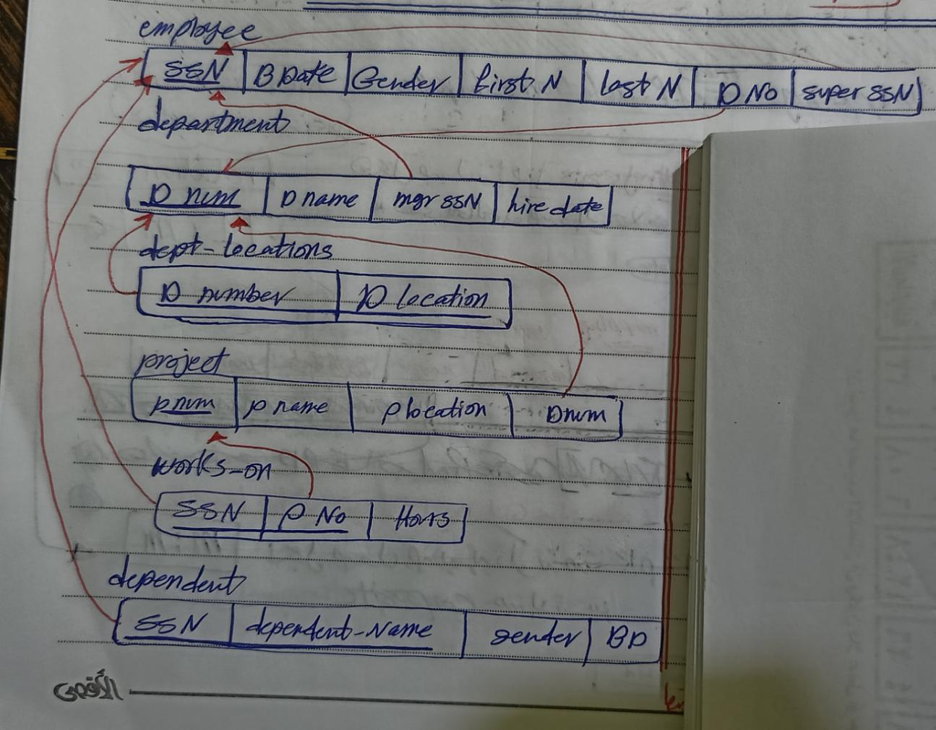  
  
  
  
  
  
  
  
  
  
  
   
 **Case 2**

**ITI has decided to store information about its Students and curriculums in a database. ITI has wisely chosen to hire you as a database designer. Prepare an E-R diagram for ITI that describes its activities according to The following Description:**

* ITI has a number of students in different departments(tracks), each student has St_id(unique),studentName(Fname,Lname),St_age,st_address
* Each department has dept_id(unique), dep_name
* Students takes many Courses, each course has crs_id, crs_name, crs_duration and crs_Description
* Student has a grade in each course
* Each department contains a set of instructor and each instructor in located in one department, each instructor has ins_id, ins_name, ins_salary, ins_hourRate, ins_bouns,ins_address
* For each Department, there is always one instructor assigned to manage that Department and each manager has a hiring Date
* Instructor may teach many courses and each course may be conducted by many instructors, each instructor has evaluation in each course
* Course is classified under one topic, each topic may have many courses, and each topic has top_name and top_id

**Solution of case 2 :-**  
